Faculty Senate

The Office of Shared Governance
543 Capen Hall, North Campus
Buffalo, NY 14260
Voicemail: 716-645-2003
Twitter: @UBFacultySenate
Facebook: UB Faculty Senate
#SharedGovernance
www.buffalo.edu/facultysenate
Feel free to contact us with any questions/concerns you might have!

Faculty Senate Committees

Academic Freedom and Responsibility
Chair: Marla Segol marlaseg@buffalo.edu
This committee will review, report and recommend to the senate matters concerning policies, procedures and actions within the university regarding academic freedom and academic responsibility.

Academic Planning and Assessment
Chair: Diane Christian engdc@acsu.buffalo.edu
This committee will review, report and recommend to the senate matters concerning the future of the university and proposals for the formation, reorganization or dissolution of academic units.

Academic Policies and Grading
Chair: Michael Cowen cowen@math.buffalo.edu
This committee will:
- Review, report and recommend to the senate matters concerning admissions to the university, the departments and to major fields, and matters concerning the recruitment of students.
- Review the grading policies of the university, including the range of grading options, the meaning of various grades, the applicable deadlines for submission of grades, procedures for grade changes, and other matters pertaining to grading that may be of faculty interest; and shall also monitor grade distribution and any apparent inflation or erosion of grades.
- Review, report and recommend to the senate matters concerning academic policy in the university, including (but not limited to) undergraduate, graduate and professional degree requirements; graduation standards; faculty evaluation of academic performance of undergraduate students; and university facilities for educational programs.

Budget Priorities
Chair: Peter Elkin elkinp@buffalo.edu
This committee will appropriately consult, review, report and recommend to the senate and shall advise the Senior Administration on matters concerning the development of the university budget and shall recommend criteria for the allocation for university budgeted funds related to the initiation, development, and implementation of the educational program.

Bylaws
Chair: Richard Gronostajski rgron@buffalo.edu
This committee will review, report and recommend to the senate matters concerning amendments to the Charter of the Faculty Senate and to the bylaws of the voting faculty, and matters concerning bylaws, standing orders and special orders of the senate.

Elections
Chair: Cynthia Tysick cat2@buffalo.edu
This committee will:
- Review, report and recommend to the senate rules and regulations for the conduct of faculty elections and referenda (including, but not limited to, rules governing apportionment of senatorial seats to electoral units, consistent with article iv, paragraphs three and four of this charter).
- Assign faculty members to electoral units consistent with the provision of article iv, paragraph two of this charter.
- Supervise faculty elections and referenda, administering the procedures, rules and regulations promulgated by the senate and by this charter.

Equity and Diversity
Chair: Glenna Bett bett@buffalo.edu
This committee will review, report and recommend to the senate on issues and practices pertaining to:
- Affirmative action in the recruitment, appointment and retention of faculty members.
- Improvement of intergroup relations and communications.
- Reduction of prejudice at the university.
- Minimizing salary equity issues.

Faculty Senate Executive Committee
Chair: Philip Glick glicklab@buffalo.edu
The Faculty Senate Executive Committee is the “committee on committees” and will review, report and recommend to the senate matters concerning university governance and governance of academic units.

Information Technology
Chair: Valerie Nesset vmnesset@buffalo.edu
This committee will:
- Conduct regular reviews of policies and practices of the university computing services, and other information resources and services including such matters as operational aspects, facilities, and general policies for future development.
- Maintain continuous liaisons with the Chief Information Officer, the director of the educational communications center, and other appropriate university officers concerned with the development, integration, and administration of information resources.
- Carry out such specific studies or investigations regarding informational resources as may be assigned to it by the executive committee.

Library Committee
Chair: Damien Keane dkeane@buffalo.edu
This committee will:
- Conduct regular reviews of policies and practices of the university libraries and other information resources and services including such matters as operational aspects, facilities, and general policies for future development.
- Maintain continuous liaisons with the director of the libraries and other appropriate university officers concerned with the development, integration, and administration of information and library resources.
- Carry out such specific studies or investigations regarding library resources as may be assigned to it by the executive committee.

Research and Creative Activities
Chair: Robert Burkard rfb@acsu.buffalo.edu
This committee will review, report and recommend to the senate matters concerning university policies, procedures and actions regarding research and creative activity; university facilities for research and creative activity; funding for research and creative activity; and responsibilities and liabilities of researchers.

Teaching and Learning
Co-chairs: James Jensen jjensen@buffalo.edu
And Lisa Stephens stephens@buffalo.edu
This committee will review, report and recommend to the senate matters concerning the conduct of teaching within the university and procedures for the evaluation of such teaching.

Tenure, Promotion, and Privileges
Chair: Susan Udin sudin@buffalo.edu
This Committee will review, report and recommend to the senate matters concerning standards within the university regarding appointment, promotion and tenure of faculty, and matters concerning faculty rights and privileges.

The first Faculty Senate Executive Committee of the 2016-2017 academic year.

The University at Buffalo Faculty Senate serves as an independent governance body representing the voting faculty (and the university) on educational policies as stipulated in the Bylaws of the Voting Faculty, the Charter of the Faculty Senate, and the Standing Orders of the Faculty Senate. The University at Buffalo Faculty Senate currently represents more than 1,700 full-time voting faculty. The Faculty Senate meets once a month and the Faculty Senate Executive Committee meets thrice a month during the academic year; guests are always welcome. The Faculty Senate has thirteen standing committees that do a herculean amount of work for the senate.
-Dr. Philip L. Glick, Chair of the Faculty Senate

Shared Governance
The SUNY Governance Handbook defines shared governance as the “structures and processes through which faculty, professional staff, administration, governing boards, and students participate in the development of policies and in decision making that affect the institution.”
The University at Buffalo is made up of Five Pillars – Administration, Faculty, Staff, Students, and UB Council with the Alumni Association.
Shared Governance Day at the University at Buffalo is celebrated on the first Tuesday in March annually.
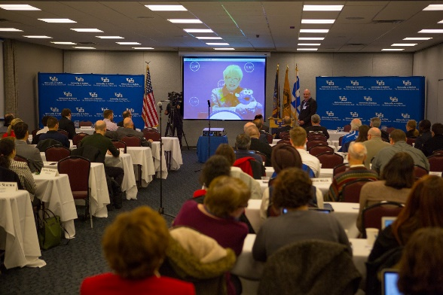Chancellor Nancy Zimpher via teleconference on Shared Governance Day in March 2016.

